Prompt 1: Cria uma atividade sobre "eco-friendly house" para alunos do 8º ano, 3º ciclo.

Eco-Friendly House

Atividade de Inglês – 8.º Ano (3.º Ciclo)

Tema: Sustainable Living / Eco-Friendly House**

1. Warm-up (Speaking)

Look at the ideas below.

Which ones are eco-friendly?
* solar panels
* leaving lights on
* recycling bins
* long showers
* bicycles
* plastic bags
* rainwater collection
* planting trees

Discuss with your partner:

1. What can make a house eco-friendly?
2. What eco-friendly habits do you have at home?
3. Would you like to live in an eco-house? Why?

2. Vocabulary Match

Match the words to the definitions.

| A | B |
| --------------- | ---------------------------------------- |
| 1. solar panels | a) using objects again |
| 2. recycling | b) energy from the sun |
| 3. reusable | c) friendly to nature |
| 4. eco-friendly | d) something that can be used many times |
| 5. save water | e) use less water |

3. Reading

The Green House

The Green House is a modern eco-friendly home in Portugal.
It uses solar panels to produce electricity and collects rainwater to water the garden. The family separates rubbish for recycling and tries to reduce plastic use.

Inside the house, the lights are LED and the windows are large to use natural light. The family also rides bicycles instead of using the car for short distances.

Thanks to these habits, the family saves energy, saves money, and helps protect the environment.

4. Reading Comprehension

True or False?

1. The Green House wastes a lot of water. _____
2. The family recycles rubbish. _____
3. The house uses solar energy. _____
4. The family always uses the car. _____
5. Large windows help save electricity. _____

Answer the questions.

1. What does the house collect?
2. What type of lights does the house use?
3. Why do the family use bicycles?
4. How does the family help the environment?

5. Grammar Focus – Should / Shouldn’t

Complete the sentences.

1. We __________ recycle plastic bottles.
2. People __________ waste water.
3. Families __________ use reusable bags.
4. You __________ leave lights on all day.
5. We __________ protect the planet.

6. Writing Activity

Design Your Eco-Friendly House

Imagine your perfect eco-friendly house.

Write **60–80 words** about it. Include:

* energy source
* water use
* transport
* recycling habits
* garden or green areas

Useful Expressions:

* My eco-house has…
* It uses…
* We recycle…
* There are…
* We save energy by…

7. Creative Task (Optional)

Draw Your Eco-Friendly House

Label at least:

* solar panels
* recycling bins
* garden
* water tank
* bicycles

8. Mini Project (Group Work)

Create a Poster:

“How to Make Our Homes Greener”

Include:

* pictures
* eco-friendly tips
* slogans
* colours and symbols

Possible slogans:

* “Save the Planet!”
* “Go Green!”
* “Small Changes, Big Difference!”

Prompt 2: Cria uma atividade sobre Eco-Friendly House para alunos do 8ºano, 3º ciclo, para a disciplina de Inglês. A atividade deve ter uma descrição de uma casa real, criada por um arquiteto, fotos e deve conter igualmente uma descrição dos elementos que a tornam sustentável e a distingue das outras.

# Eco-Friendly House – 8th Grade English Activity

## “The Nautilus House” – A Real Eco-Friendly Home

Eco-Friendly House – 8th Grade English Activity
“The Nautilus House” – A Real Eco-Friendly Home
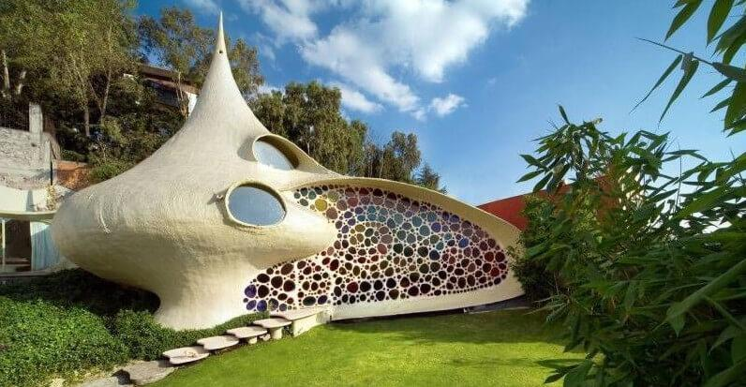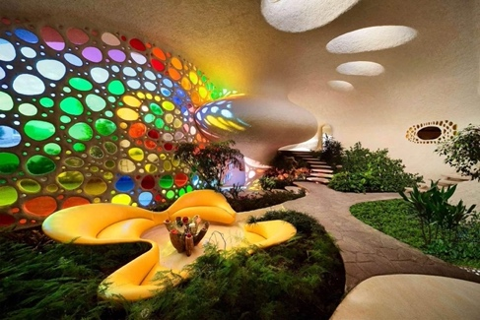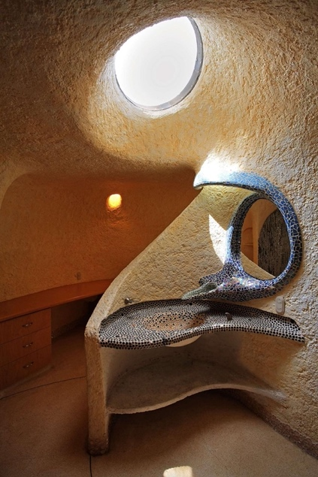

The Nautilus House was designed by the Mexican architect Javier Senosiain.
This unusual house was inspired by the shape of a seashell and by nature itself. The architect wanted to create a home that connected people with the environment and reduced the negative impact on nature.
The house has curved walls, colourful st

The **Nautilus House** was designed by the Mexican architect **Javier Senosiain**.
This unusual house was inspired by the shape of a seashell and by nature itself. The architect wanted to create a home that connected people with the environment and reduced the negative impact on nature.

The house has curved walls, colourful stained-glass windows, natural light, plants inside the home, and organic shapes instead of traditional straight lines. Many of the materials used were chosen to make the house more energy-efficient and environmentally friendly.

### Sustainable Features of the House

* Large windows provide natural light and reduce electricity use.
* Plants inside and outside improve air quality.
* The shape of the house helps maintain a comfortable temperature naturally.
* Natural and recycled materials were used in construction.
* The design respects nature and blends with the surrounding environment.

### Why Is It Different?

* It looks like a giant shell instead of a traditional square house.
* It combines architecture with nature.
* The interior feels open, bright, and connected to the outdoors.
* It focuses on sustainability and wellbeing.

---

# Reading Activity

## Part A – Read and Answer

1. Who designed the Nautilus House?
2. What inspired the design of the house?
3. How does the house save energy?
4. Why are plants important in this eco-friendly home?
5. What makes this house different from ordinary houses?

---

# Vocabulary Match

Match the words with their meanings.

| Word | Meaning |
| ------------------------- | ---------------------------------- |
| 1. Sustainable | a. Friendly to nature |
| 2. Natural light | b. Materials used to build |
| 3. Recycled | c. Light from the sun |
| 4. Eco-friendly | d. Used again |
| 5. Construction materials | e. Able to protect the environment |

---

# Speaking Activity

Work with a partner and discuss:

* Would you like to live in this house? Why / Why not?
* What eco-friendly elements would you add to your dream house?
* Do you think sustainable houses are important for the future?

---

# Creative Writing Task

Imagine your own eco-friendly house. Write a short paragraph (60–80 words) describing:

* where the house is,
* what it looks like,
* what sustainable elements it has,
* why it is environmentally friendly.

You may include:

* solar panels,
* rainwater collection,
* rooftop gardens,
* recycled materials,
* wind energy,
* smart technology.

---

# Extension Activity (Optional)

Draw your dream eco-friendly house and label at least 5 sustainable features in English.
Prompt 3

Prompt 3: Ajuda-me a escrever um prompt eficaz para pedir a uma IA que crie uma atividade sobre eco-friendly houses para alunos do 8º ano, 3º ciclo, para a disciplina e Inglês A atividade deve ter um exemplo de uma casa real, com imagens e descrição das suas qualidades sustentáveis.

Pode usar um prompt mais específico e estruturado para obter resultados mais completos e adequados ao nível dos alunos. Por exemplo:

> Cria uma atividade didática em inglês sobre “Eco-Friendly Houses” para alunos do 8º ano (3.º ciclo).
> A atividade deve ser adequada a alunos com nível de inglês A2/B1 e incluir:
> * um título apelativo;
> * uma breve introdução ao tema da sustentabilidade;
> * a descrição de uma casa ecológica real criada por um arquiteto verdadeiro;
> * imagens da casa (exterior e interior);
> * explicação simples das características sustentáveis da casa (ex.: painéis solares, luz natural, materiais reciclados, isolamento térmico, reaproveitamento de água, jardins, etc.);
> * vocabulário útil relacionado com sustentabilidade e habitação;
> * exercícios variados, como compreensão de leitura, verdadeiro/falso, escolha múltipla, matching e expressão escrita;
> * uma pequena atividade oral ou de discussão;
> * instruções claras para os alunos;
> * linguagem simples, motivadora e adequada à faixa etária.
>
> Organiza a atividade de forma visual e pronta a imprimir.
> Inclui também as soluções dos exercícios no final.

Também pode acrescentar pedidos mais específicos, como:

* “torna a atividade dyslexia-friendly”;
* “inclui diferenciação pedagógica”;
* “usa cores e ícones”;
* “cria uma versão digital para Google Classroom”;
* “inclui critérios de avaliação”.

# ECO-FRIENDLY HOUSES

## English Activity – 8th Grade (A2/B1)

### Name: _______________________________

### Class: ____________ Date: ____________

---

# What Is an Eco-Friendly House?

An eco-friendly house is a home that helps protect the environment. These houses use less energy and water and are often built with sustainable materials. They are designed to make people comfortable while reducing pollution and waste.

---

# A Real Eco-Friendly House
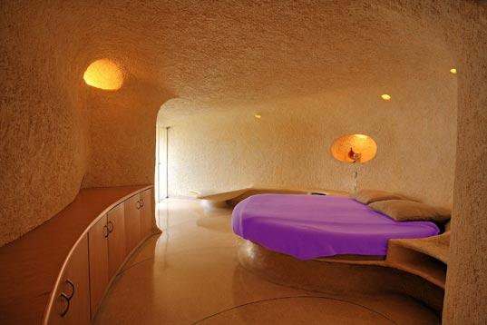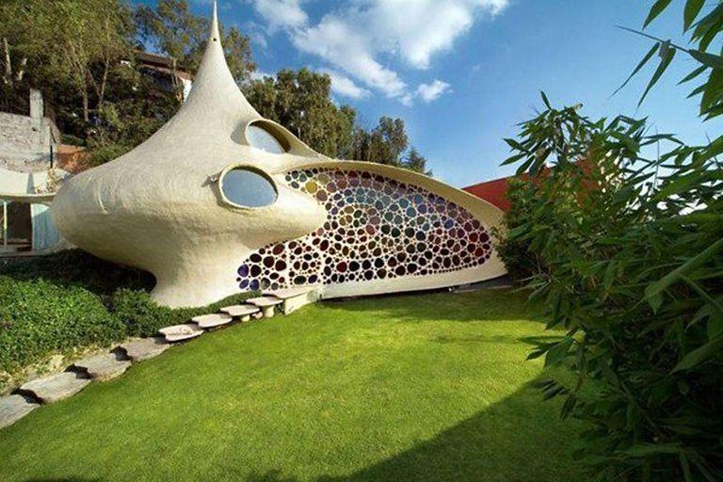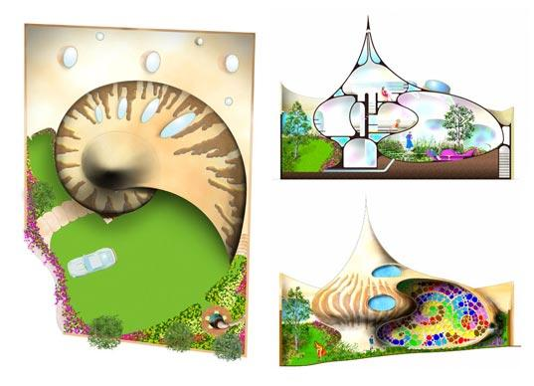
## The Nautilus House

The **Nautilus House** was designed by the architect **Javier Senosiain**.

This amazing house looks like a giant seashell. The architect wanted to create a home that connected people with nature. The house has curved walls, colourful windows, plants inside the house, and many natural elements.

The Nautilus House is eco-friendly because it uses natural light, natural ventilation, and energy-efficient design. The plants help clean the air, and the organic shape helps keep the house cool in summer and warm in winter.

The house is different from ordinary homes because it does not have many straight lines or traditional rooms. It feels like living inside nature.

---

# Sustainable Features

## Why is this house eco-friendly?

✅ Large windows reduce the need for electric lights.
✅ Plants improve air quality.
✅ Natural ventilation keeps the house fresh.
✅ Organic design helps control temperature naturally.
✅ The house blends with nature.

---

# Vocabulary Box

| Word | Meaning |
| ------------- | ----------------------------------- |
| Sustainable | Good for the environment |
| Natural light | Light from the sun |
| Ventilation | Fresh air moving through a building |
| Recycled | Used again |
| Eco-friendly | Not harmful to nature |

---

# Exercise 1 – Reading Comprehension

Answer the questions.

1. Who designed the Nautilus House?

---

2. What inspired the design of the house?

---

3. How does the house save energy?

---

4. Why are there plants inside the house?

---

5. What makes this house different from normal houses?

---

---

# Exercise 2 – True or False

Write **T (True)** or **F (False)**.

1. ___ The Nautilus House is in England.
2. ___ The house uses natural light.
3. ___ The architect wanted a connection with nature.
4. ___ The house is shaped like a cube.
5. ___ Plants help improve the air quality.

---

# Exercise 3 – Match the Words

| A | B |
| ---------------- | --------------------- |
| 1. Sustainable | a. Fresh air |
| 2. Ventilation | b. Friendly to nature |
| 3. Natural light | c. Used again |
| 4. Recycled | d. Light from the sun |

---

# Speaking Activity

Work with a partner.

Discuss these questions:

* Would you like to live in this house? Why / Why not?
* What eco-friendly elements would you add to your dream home?
* Do you think eco-friendly houses are important for the future?

---

# Writing Activity

## My Dream Eco-Friendly House

Write 60–80 words about your ideal eco-friendly house.

Include:

* where it is,
* what it looks like,
* sustainable elements,
* why it is environmentally friendly.

You may use these ideas:

* solar panels,
* rooftop garden,
* recycled materials,
* rainwater collection,
* smart technology,
* wind energy.

---

# OPTIONAL CREATIVE TASK 🎨

Draw your dream eco-friendly house and label 5 sustainable features in English.

---

# TEACHER’S KEY

## Exercise 1

1. Javier Senosiain designed the house.
2. A seashell and nature inspired the design.
3. It uses natural light and natural ventilation.
4. Plants improve air quality.
5. Its organic shape and connection with nature make it different.

## Exercise 2

1. F
2. T
3. T
4. F
5. T

## Exercise 3

1 – b
2 – a
3 – d
4 – c

